composer create-project --prefer-dist laravel/laravel blog

composer require spatie/laravel-permission

composer require laravelcollective/html

**config/app.php**

'providers' => [

Spatie\Permission\PermissionServiceProvider::class,

],

php artisan vendor:publish --provider="Spatie\Permission\PermissionServiceProvider"

**For Test**

php artisan make:model Product -m

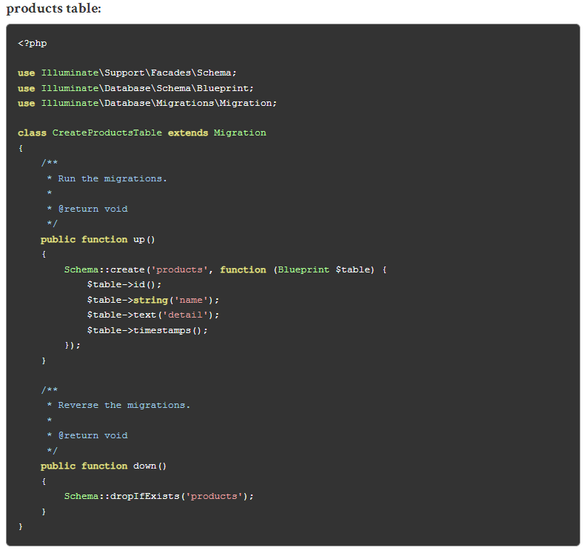

php artisan migrate

**app/Models/User.php**

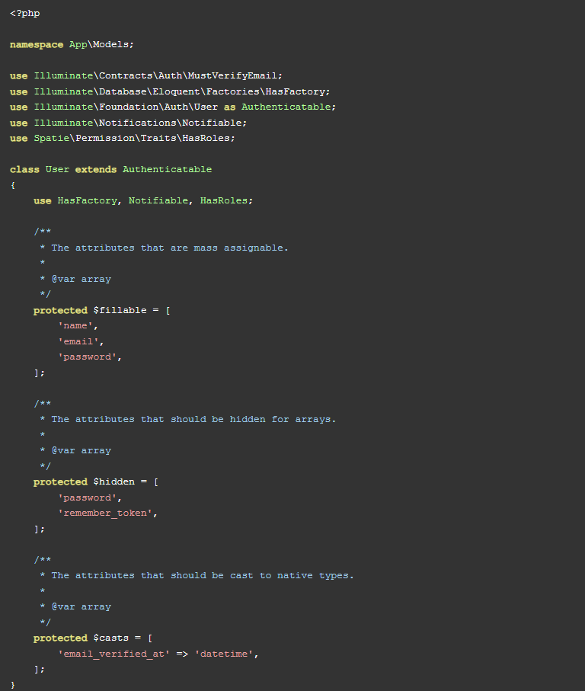

**app/Models/Product.php**

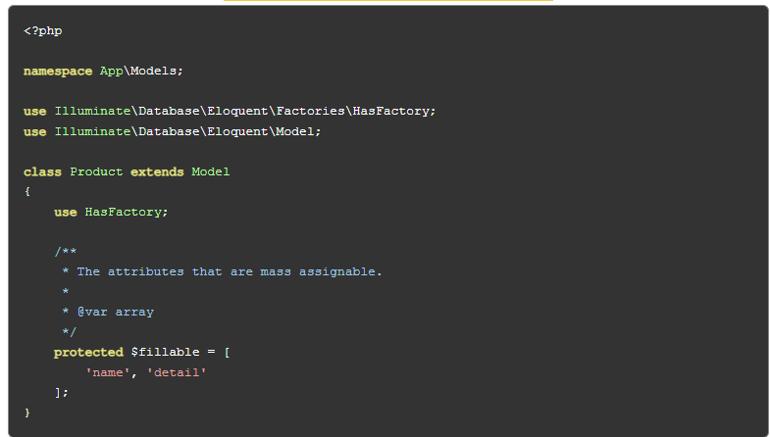

php artisan migrate

Spatie package provide it's in-built middleware that way we can use it simply and that is display as bellow:

**role**

**permission**

So, we have to add middleware in Kernel.php file this way :

**app/Http/Kernel.php**

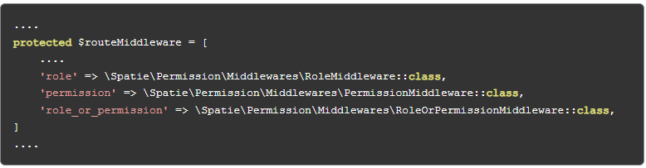

After installation and setup auth(breez-flow to Laravel official documantation)

After flow code then

In this step we will create seeder for permissions, Right now we have fixed permission so we create using seeder as listed bellow, but if you can add more permission as you want:

1.role-list

2.role-create

3.role-edit

4.role-delete

5.product-list

6.product-create

7.product-edit

8.product-delete

php artisan make:seeder PermissionTableSeeder

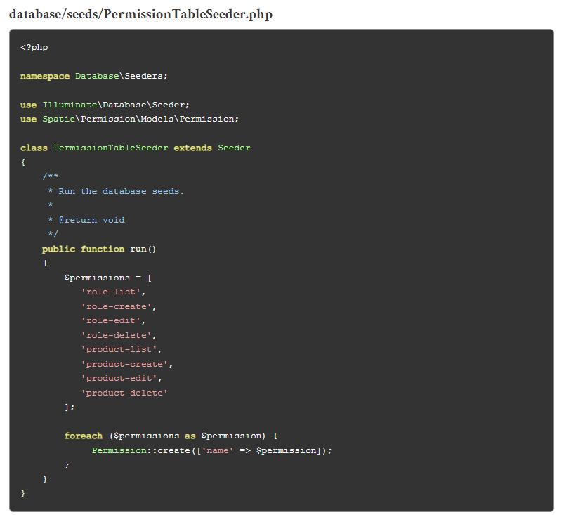

php artisan db:seed --class=PermissionTableSeeder

php artisan make:seeder CreateAdminUserSeeder

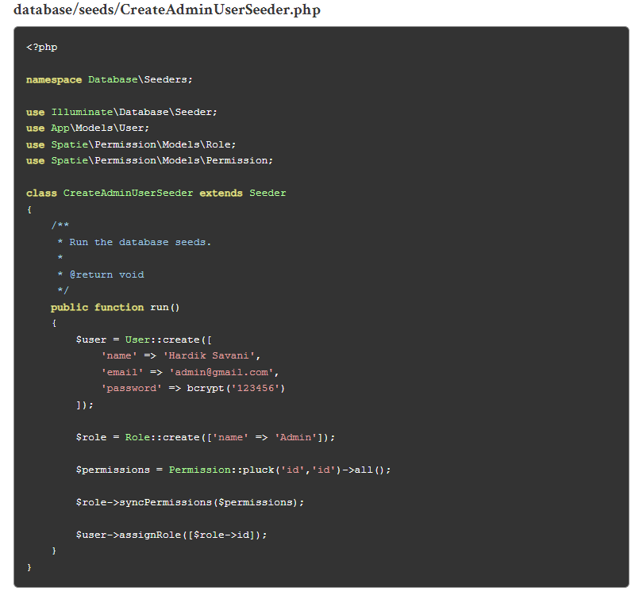

php artisan db:seed --class=CreateAdminUserSeeder

php artisan serve